Registreerimise tulemused 26.02-28.02.2016 EMV-tele

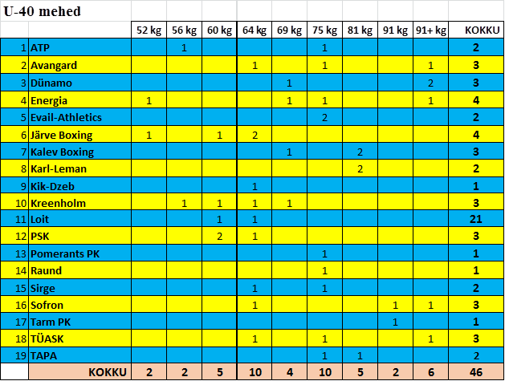

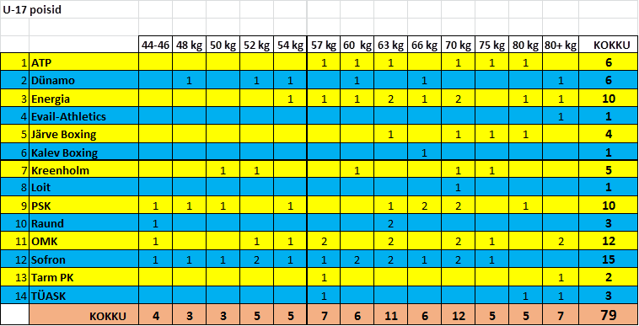

Naised U40
 | 57 kg | 60 kg | 69 kg | KOKKU
OMK | 1 |  |  | 1
TÜASK |  |  | 1 | 1
Dünamo |  | 1 |  | 1
KOKKU | 1 | 1 | 1 | 3

