INVITATION

It is our great pleasure to invite your National Federation Teams to participate in the
International Tallinn OPEN Boxing Tournament in Tallinn, Estonia.
The tournament will be held at Lasnamäe Sporthall (address Pae 1, Tallinn, 2.floor).
Accommodation will take place at Hestia Hotel Susi (address Peterburi tee 46, Tallinn).
The tournament period is September 23rd-25th, 2022.
The deadline for registration is September 15th 2022.
Entries must be sent to Mrs. Jelena Kalbina (estboxing@gmail.com) via email.
We are also pleased to give you more information if required.

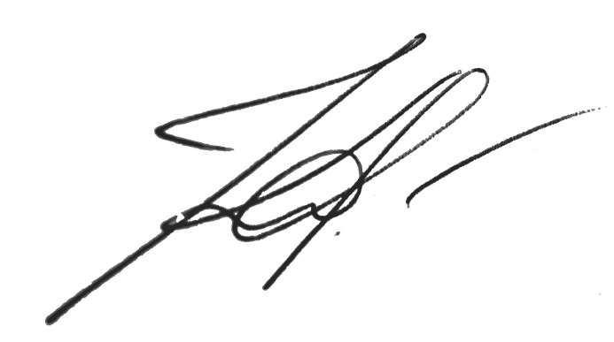

Jelena Kalbina
Secretary General

TOURNAMENT SCHEDULE

Friday, 23.09.2022 | 09.00- 11.00 | Medical Examination and General Weigh-in – Lasnamäe Sporthall, Pae 1, Tallinn, 2.floor
 | 11.15-12.15 | Official Draw - Lasnamäe Sporthall, Pae 1, Tallinn, 2. floor
 | 15.00 | Preliminaries U15, U17, U19, U40 - Lasnamäe Sporthall, Pae 1, Tallinn, 2. floor
Saturday, 24.09.2022 | 09.00- 10.00 | Medical Examination and Weigh-in – Lasnamäe Sporthall, Pae 1, Tallinn, 2. floor
 | 13.00 | Semifinals U15, U17, U19, U40 - Lasnamäe Sporthall, Pae 1, Tallinn, 2. floor
Sunday, 25.09.2022 | 09.00- 10.00 | Medical Examination and Weigh-in – Lasnamäe Sporthall, Pae 1, Tallinn, 2. floor
 | 13.00 | Semifinals U15, U17, U19, U40 – Lasnamäe Sporthall, Pae 1, Tallinn, 2. floor

REGULATIONS

The Tournament shall be organized according the IBA Technical and Competition rules.

WEIGHT CATEGORIES

Elite men: 13 weight categories
46 – 48 kg, 51 kg, 54 kg, 57 kg, 60 kg, 63,5 kg, 67 kg, 71 kg, 75 kg, 80 kg, 86 kg, 92kg, 92+ kg;

Elite women: 12 weight categories
45 – 48 kg, 50 kg, 52 kg, 54 kg, 57 kg, 60 kg, 63 kg, 66 kg, 70 kg, 75 kg, 81 kg, 81+ kg.

Youth men: 13 weight categories
46 – 48 kg, 51 kg, 54 kg, 57 kg, 60 kg, 63,5 kg, 67 kg, 71 kg, 75 kg, 80 kg, 86 kg, 92kg, 92+ kg;

Youth men: 12 weight categories
45 – 48 kg, 50 kg, 52 kg, 54 kg, 57 kg, 60 kg, 63 kg, 66 kg, 70 kg, 75 kg, 81 kg, 81+ kg.

Junior men and women: 13 weight categories
44 kg - 46 kg, 48 kg, 50 kg, 52 kg, 54 kg, 57 kg, 60 kg, 63 kg, 66 kg, 70 kg, 75 kg, 80 kg ja 80+ kg

Schoolboys: 16 weight categories
37-40 kg, 42 kg, 44 kg, 46 kg, 48 kg, 50 kg, 52 kg, 54 kg, 57 kg, 60 kg, 63 kg, 66 kg, 70 kg, 75 kg, 80 kg, 90 kg.

Schoolgirls: 13 weight categories
34kg-36kg, 38kg, 40kg, 42kg, 44kg, 46kg, 48kg, 51kg, 54kg, 57kg, 60kg, 64kg, 70kg.

Participation is limited to two (2) boxer per club per weight category.

REQUIREMENTS
All boxers must bring along with them:
• International IBA Competition Record Book (medical examination stamped by doctor max. 12 months old)
• Passport or ID card
• Two sets of Boxing Uniforms (red/blue) according to IBA Technical and Competition rules

INSURANCE
All participants are responsible for their own medical insurance. The organizer does not provide medical Insurance.

ACCOMMODATION AND MEALS
The LOC will make reservation of accommodation for every team for the tournament period according with registration details. Accommodation will take place at Hestia Hotel Susi (address Peterburi tee 46, Tallinn).
The price for accommodation is 26.- eur per night per person in a twin room and 26.- eur per night per person in a triple room. Single room costs 48.- eur per night per person.
The price includes breakfast, parking, taxes and WiFi.
Payment for accommodation will be required directly at the hotel reception while arrival (no prepayment needed).

PARTICIPATION FEE
Every team will be obligated to pay participation fee 20.- eur per boxer while general weight-in.

HOTEL

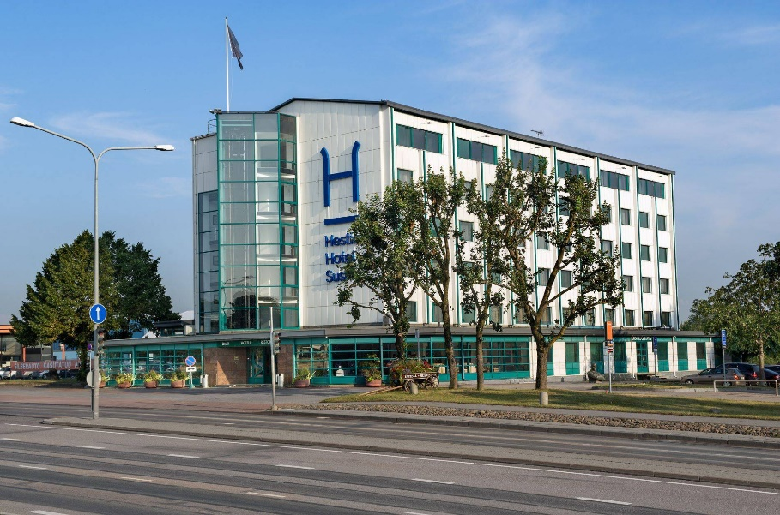
Name: Hestia Hotel Susi
Address: Peterburi tee 46, Tallinn

COMPETITION & TRAINING VENUES

Name: Lasnamäe Spordikompleks
Address: Pae 1, Tallinn (2.floor)

